# 1. Write a program which accepts a sequence of comma-separated numbers from console and

# generate a list.

getsequence = input ("Input numbers with comma separated :" )

ListNumber= getsequence.split(',')

print("Answer 1" )

print(ListNumber)

# End#

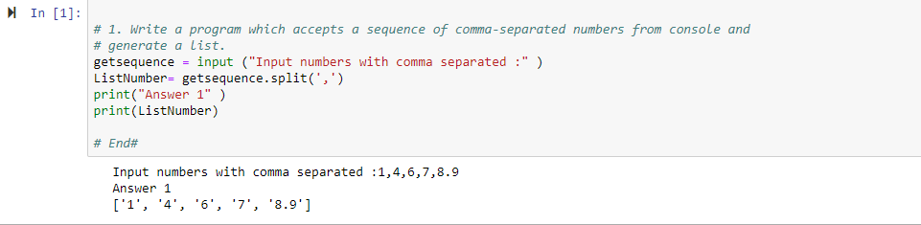

"""

#2. Create the below pattern using nested for loop in Python.

*

* *

* * *

* * * *

* * * * *

* * * *

* * *

* *

*

"""

print("Answer 2")

print("* " * 1 )

print("* " * 2)

print("* " * 3)

print("* " * 4)

print("* " * 5)

print("* " * 4)

print("* " * 3)

print("* " * 2)

print("* " * 1)

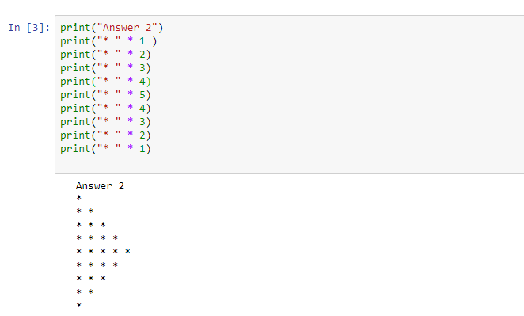

#3.3. Write a Python program to reverse a word after accepting the input from the user.

#Sample Output:

#Input word: AcadGild

#Output: dilGdacA

wordreverse=input("Enter any word for reversing: ")

print("Answer 3")

print("Reversed Word:"+ wordreverse[::-1])

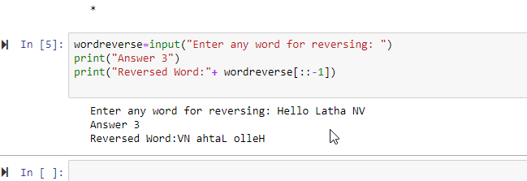

#

#4.4. Write a Python Program to print the given string in the format specified in the â€‹sample output.

#WE, THE PEOPLE OF INDIA, having solemnly resolved to constitute India into a SOVEREIGN, SOCIALIST, SECULAR, DEMOCRATIC REPUBLIC and to secure to all its citizens

#Sample Output:

print("Answer 4")

print("WE, THE PEOPLE OF INDIA")

print(" having solemnly resolved to constitute India into a SOVEREIGN, !")

print(" SOCIALIST, SECULAR, DEMOCRATIC REPUBLIC ")

print(" and to secure to all its citizens")

